**Insert Client Logo**



**Direct Administrator User Guide**

**Release 5.14.0**

**November 2014**

# INTRODUCTION

Direct messaging is a method for secure transmission of protected health information (PHI) over the Internet. A Direct messaging system:

* allows users to communicate with other users within their own HIE and other health information networks
* provides an integrated directory to easily find users in the same network
* offers the ability to delegate a mailbox to another Direct user to send/receive messages for a different account.

Specifics about using the Direct messaging system can be found in the “Direct Messaging User Guide”.

This Direct Administrator User Guide focuses on the webclient tools available for setting up the Direct environment, including the creation of Direct domains, managing digital certificates, and creating user associations to the Direct environment.

# Direct Administration

The Direct Administration features can be accessed by clicking **Direct Administration** on the webclient dashboard. There is also a link to Direct Administration in the **Administration** menu on the navigation bar.

The **Direct Administration** tab of the Direct Administration screen gives quick access to all of the tools needed to manage Direct domains.

On the Direct Administration main screen, you will see a list of all current Direct domains that are associated with the HIE. Each domain will have a separate dashboard, showing the details of that domain.

Dashboards for multiple domains can be viewed by using the scroll bar at the right, or by searching for the domain name using the *Search* box in the upper-right.

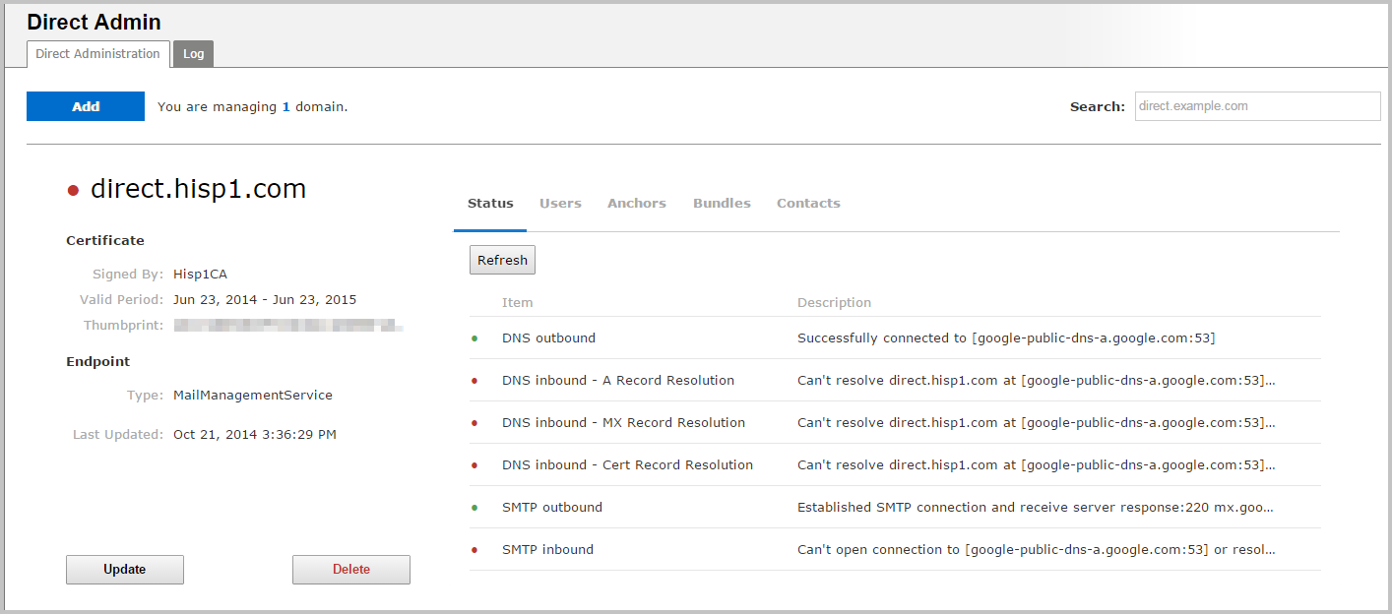

## Domain Dashboards

### General Information Panel

General information about a Direct domain is available at the left of each domain dashboard.

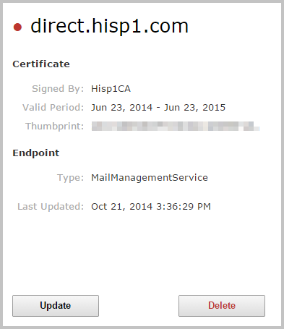

This part of the dashboard shows basic information about the domain, including:

* the Direct domain’s name
* the certificate authority which signed the Domain’s certificate
* the certificate’s dates of validity
* the certificate’s thumbprint (a string of characters generated from the certificate that is unique to that certificate)
* the domain’s endpoint type (information about endpoint types can be found in the “Adding a Domain” section)
* the last time the domain was updated

Note: within 30 days of a certificate’s expiration date, a warning message will appear in red at the bottom of the left-hand panel.

At the bottom of the general info panel, there are two buttons: **Update**, which allows the domain’s certificate to be updated, and **Delete**, which removes the domain entirely.

### Specific Info Panel

To the right of the domain’s general info panel, there are five tabs which contain more detailed information about the domain. Each tab can be selected by clicking it.

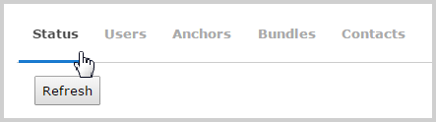

The available tabs include:

* **Status:** shows information about the status of various domain connections.
* **Users:** allows management of user groups associated with the domain.
* **Anchors:** allows management of the Certificate Authority enforcing the domain’s digital certificate.
* **Bundles:** allows management on any trust bundles (groups of trust anchor certificates) used by the domain.
* **Contacts:** Displays which Direct addresses are associated with the domain.

The following sections describe each of the domain dashboard tabs in more detail:

#### ***Status***:

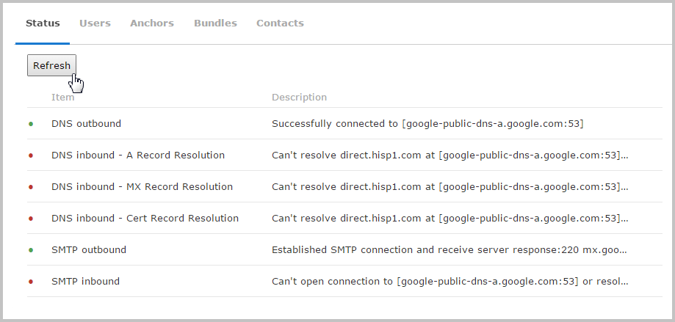

The **Status** tab shows basic status information about the Direct domain’s DNS and STMP connections. It monitors 6 different items that can be used to diagnose problems with the direct domain. The connections monitored include:

* DNS outbound
* DNS inbound—A Record Resolution
* DNS inbound—MX Record Resolution
* DNS inbound—Cert Record Resolution
* SMTP outbound
* SMTP inbound

Each item on the **Status** tab begins with a small indicator light. If the connection is functional, the light will appear green; if there is a current issue, it will appear red.

Click the **Refresh** button in the upper left to check the current status. Details about the connection’s status are listed in the *Description* column.

#### Users:

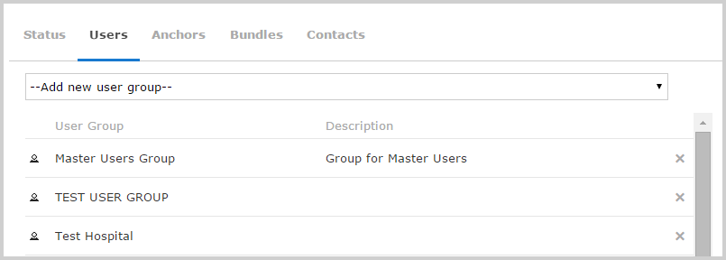

The **Users** tab allows access to the user group management functions of the Direct domain. User groups are defined in the **User Groups** section of the **User Security** page of the webclient.

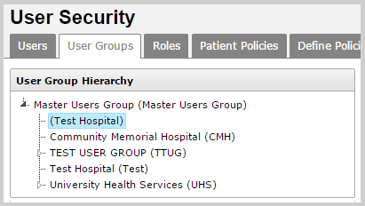

When a user group is added to a Direct domain, any users that are part of that group will have access to the Direct domain, and will be able to send Direct messages through that domain.

Note: if an added user group also has child user groups, those child groups will also have access to the Direct domain. Adding the Master Users Group will provide access for all user groups.

To add a user group to the domain, click on a selection from the dropdown menu at the top of the **Users** panel. The selection will appear in the list of user groups below. To remove a user group from the domain, click on the **X** at the right of the user group’s listing.

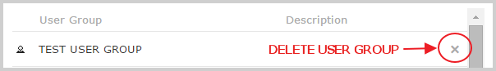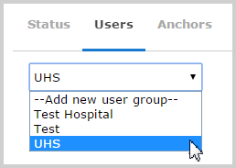

#### Anchors:

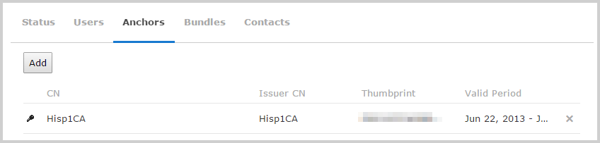

The **Anchors** tab lists all of the Certificate Authorities that are trusted by this domain. Trust is established by accepting the appropriate certificate file.

A trust anchor’s certificate can be added to the domain by clicking on **Add**, and then choosing the appropriate certificate file. Only .CER or .DER certificate files ca be added. Trust anchors can be removed from the domain by clicking on the X at the right-hand side of the certificate’s listing**.**

#### Bundles:

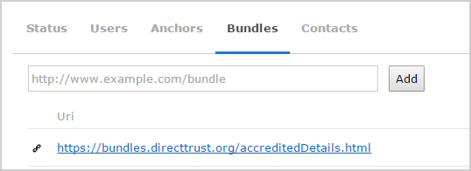

The **Bundle** tab allows collections of trust anchors to be included in the domain. These bundles allow a network of trusted certificate authorities to be managed without including individual certificates for each authority.

To add a trust bundle, type the appropriate URI in the text box and click **Add**.

Note: Bundle URIs must be entered using the standard HTTP URL scheme (e.g. <http://www.example.com/bundle>)

#### Contacts:

The **Contacts** tab allows Direct addresses and domains to be associated with a specific domain.

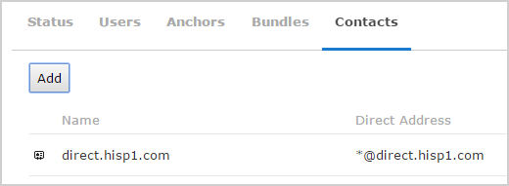

Click on the **Add** button and the *Add Contacts* window will appear.

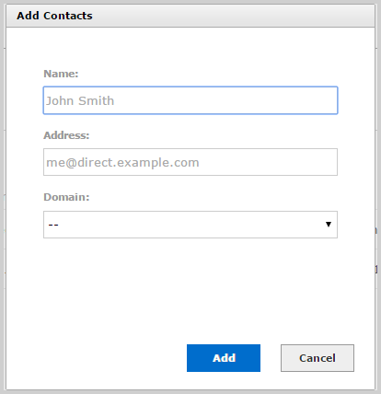

To add an individual user to the domain, type the user’s name in the *Name* box and the user’s Direct address in the *Address* box (ignore the *Domain* dropdown), and then click **Add**. The name and address will then appear in the Address Book list.

Note: Direct addresses entered in this way are not verified—any text can be entered in the *Name* or *Address* boxes.

To add all users from a Direct domain, choose a selection from the *Domain* dropdown and click **Add**. Now, all users from that domain will be associated with the current dashboard’s domain.

Once added to the address book, Direct user addresses or outside domains will be considered valid recipients for Direct users of this domain. This also means that recipients in the address book will appear as autocomplete suggestions when typed into the address fields when composing messages.

## Adding Direct Domains

To begin adding Direct messaging functionality to the HIE, a Direct domain must be added to the system. Multiple domains can be added to a single HIE.

Each domain will appear as a separate dashboard on the **Direct Administration** main page. To navigate through multiple domains, use the scroll bar at the right-hand side of the screen. The search box on the upper right of the screen can also be used to search for a specific domain name.

To add a Direct domain, click on the **Add** button at the upper left of the **Direct Administraion** screen. The *Add Domain* window will appear.

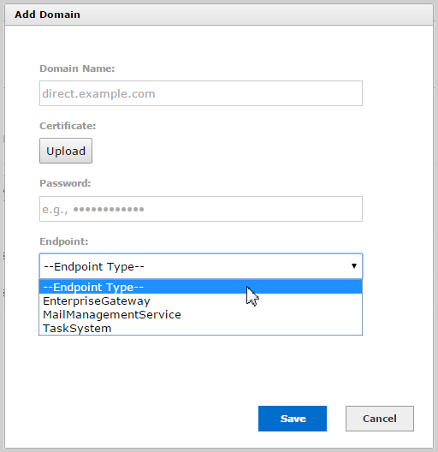

Type the domain in the box provided. The domain’s certificate can be added by clicking on the **Upload** button and selecting the appropriate .PFX file. Enter the certificate’s password in the appropriate text box.

Choose the domain’s endpoint type from the **Endpoint Type** dropdown. Endpoints can be one of three types:

* **Mail Management Service:** establishes the HISP as a messaging service
* **Enterprise Gateway:** links the HISP to relay messages to another client (such as an EMR)
* **Task System:** used for automated processing of certain files transactions (such as XDRs)

Once all the required information has been added, click **Save**. A dashboard for the domain will now appear on the main Direct Administration page.

## Direct Administration Log

When errors occur while sending and receiving Direct messages, error messages are logged by the Direct system. The **Log** tab on the **Direct Administration** screen allows access to these error messages.

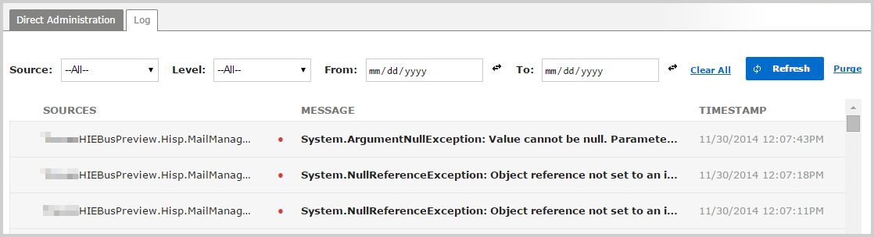

Error messages can be scrolled through using the scroll bar to the left. Once the bottom of the scroll bar is reached, more error messages will be loaded.

To get more information on a specific error message, click on it to view details in the *Message* column. Click it again to collapse the details.

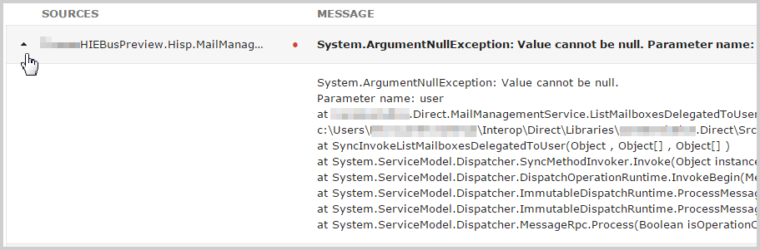

### Filtering Error Messages

The filter selections at the top of the screen can be used to narrow the list of error messages.

Click on the **Source** dropdown to select the system which generated the error. Selections include:

* **Direct Agent**
* **Direct Relay**
* **Enterprise Gateway**
* **James Host**
* **Mail Management**
* **Mail Proxy**

Click on the **Choose Level** dropdown to select the severity of the error message. Selections include:

* **Error** (a small red indicator light appears next to the listing)
* **Warning** (a small orange indicator light appears next to the listing)
* **Debug**
* **Information**
* **Unspecified**

Dates and times for specific error messages can be specified in the *From:* and *To:* text boxes. To enter times, click on the double arrow icon to the right of the text boxes.

Finally, to reset the filter selections, click on the **Clear All** link.

### Updating and Purging Error Messages

To ensure that all the most recent error messages are available, click on the **Refresh** button. To eliminate all currently stored error messages, click on the **Purge** link.